Short Term Viability of
‘The Showcase with IMAX’

Understanding the overall direction of the cinema industry as well as the major financial components of ‘The Showcase with IMAX’ is essential for forecasting project viability.
Parameters of the Analysis:
- The Showcase with IMAX is scheduled to open in the fourth quarter of 2016.
- For the sake of this discussion,
- Short Term will be defined as the first three (3) year span of a ten (10) year bank loan.
- Long Term will be defined as the subsequent seven (7) years of the aforementioned.

Determining factors of the Short Term Success
Evaluation of ‘The Showcase with IMAX’ project in the short term, requires an understanding of four constituents of the Bahamian Cinema Market:
- The State of the Bahamian customer base
- The competitors in the market
- The products available to the market
- Facility launch strategy
The first two components have been extensively covered in the business plan. The third cog, the movie slate itself, is quite relevant and equally as important for financial viability.
Products Available to the Market: Upcoming Movie Slate
Cinemas are only as good as the products shown and the experience provided. The latter can be controlled and maintained from a managerial standpoint. However, the former is completely out of the control of exhibitors globally. Fortunately for the Showcase with IMAX, 2015-2018 are said to be “The Return of the Golden Age of Cinema”. The Film Slate in the next three (3) years, has Industry and Wall Street Observers investing in the Movie Business.
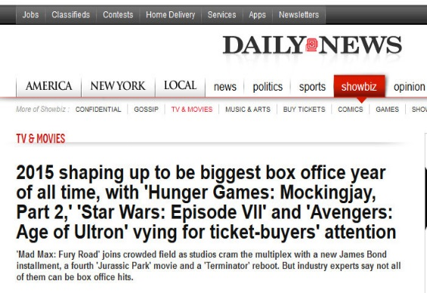

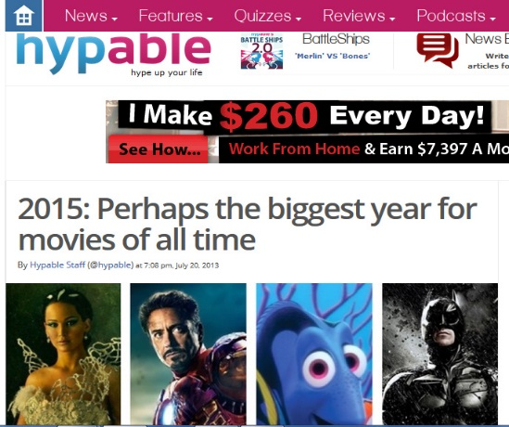

2015 Movie Slate:


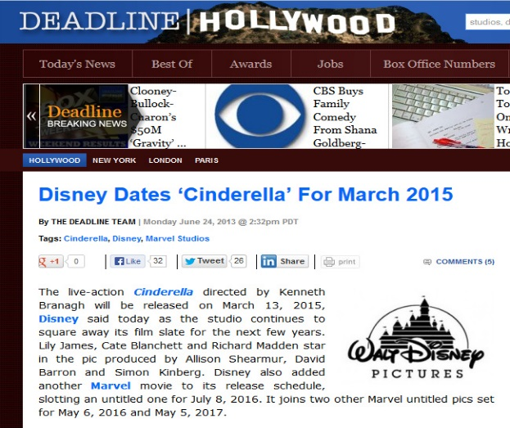
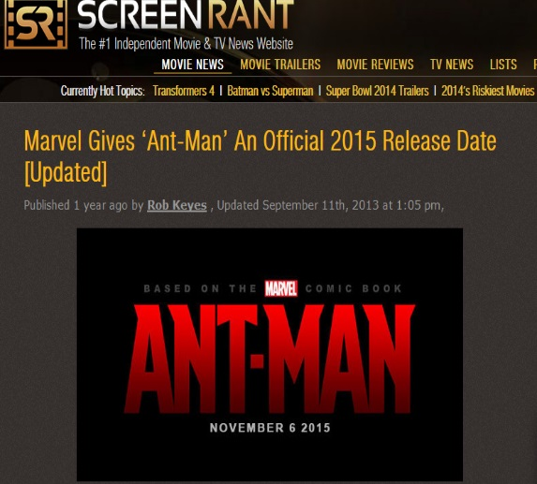
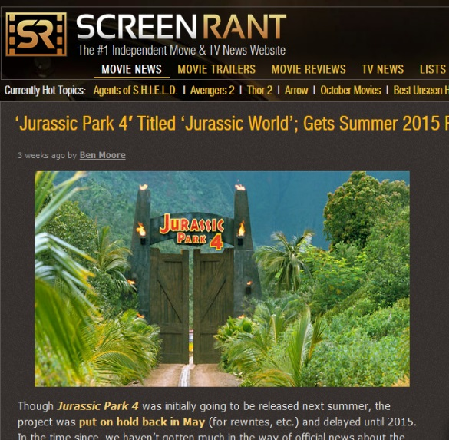
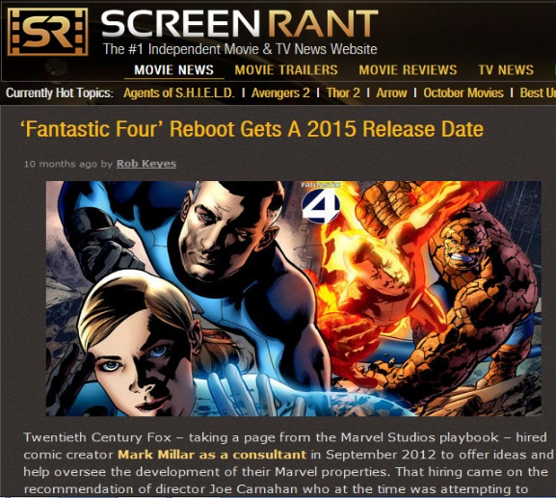
The Slate from the beginning of the year until the end is impressive to say the least
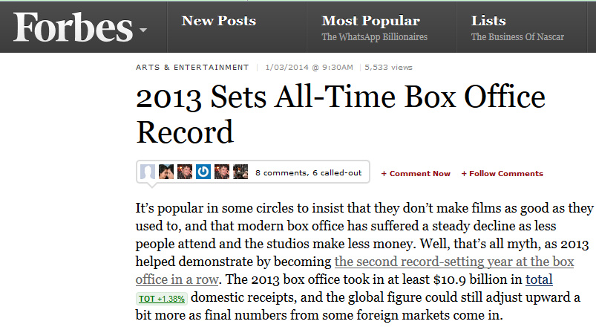
Why are all of these Movie Industry Observers, so excited about 2015?
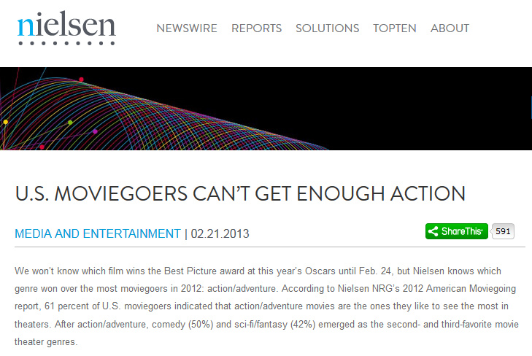
After a record breaking 2013, where only one movie (Iron Man 3) broke the $1 Billion barrier, consumers have spoken load and clear about what they want to watch.
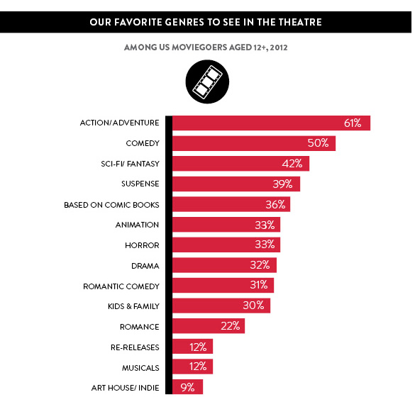
Neilson Research polled movie goers to find out what they craved. Action movies won over 60% of the audience. When comparisons between the taste of US consumers and Bahamian moviegoers are done, similarities abound.
An extensive study of the Bahamian market revealed the following:
Action and Comedies are also the two most popular genres. However, Comedies are the top category.

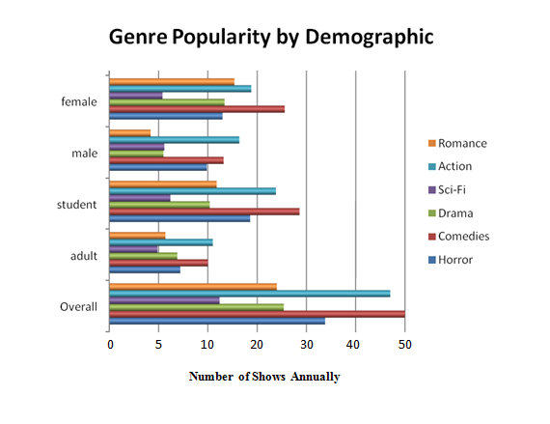
Bahamian Moviegoers Genre Preferences
This is very important for The Showcase’s feasibility.
Why?
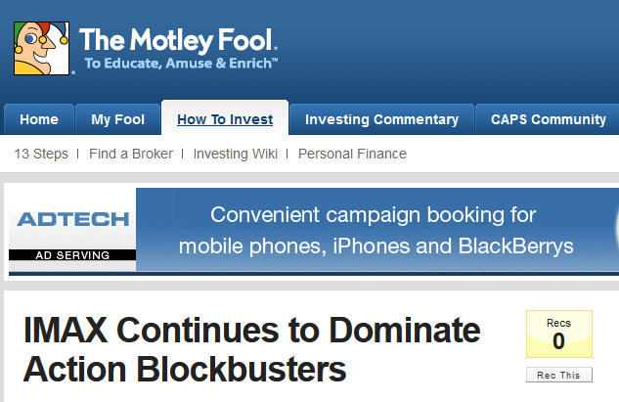
2015 is filled with a plethora of Action/Adventure movies. Who is the King of this Genre?

Industry observers are already pointing out the companies that will dominate 2015.

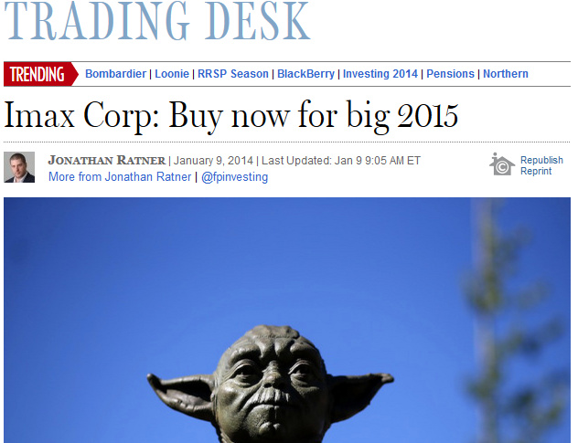
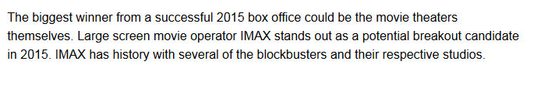
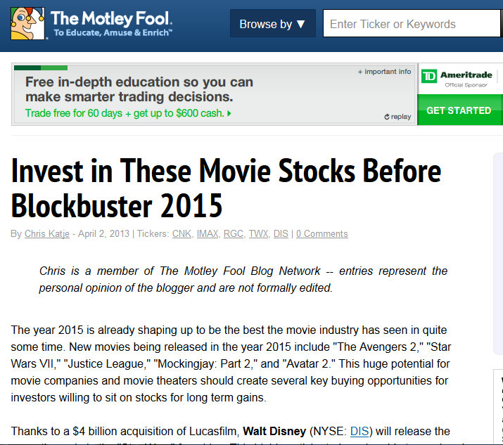
Who are they choosing? IMAX Theater OWNERS.
2016 Movie Slate
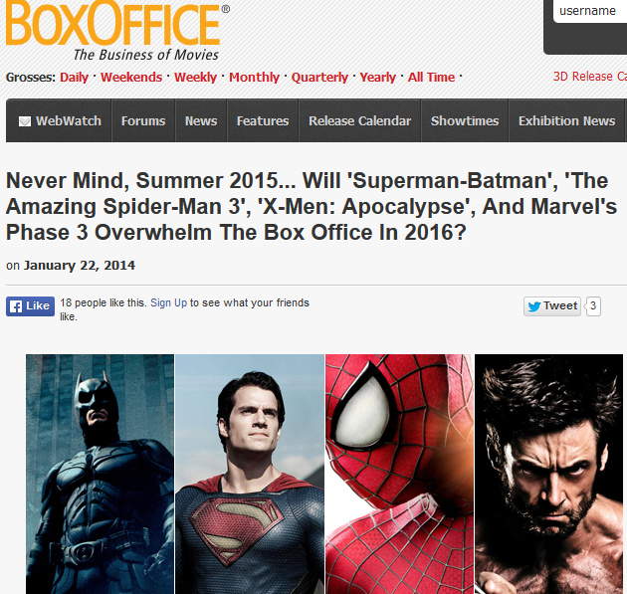
As amazing as the 2015 movie schedule is, 2016 will surpass it in every way.
Why?
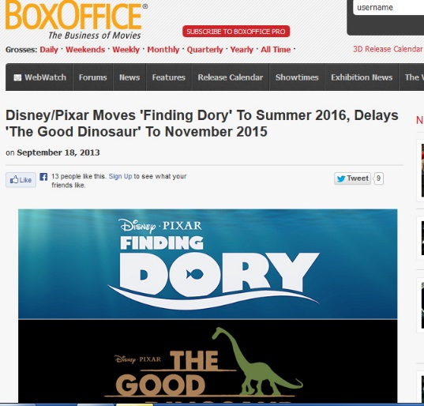
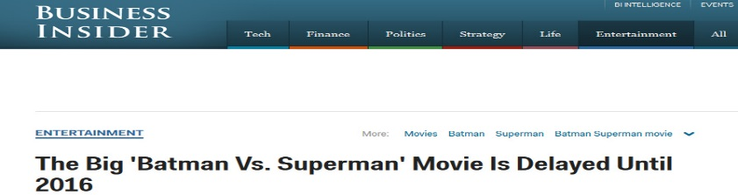
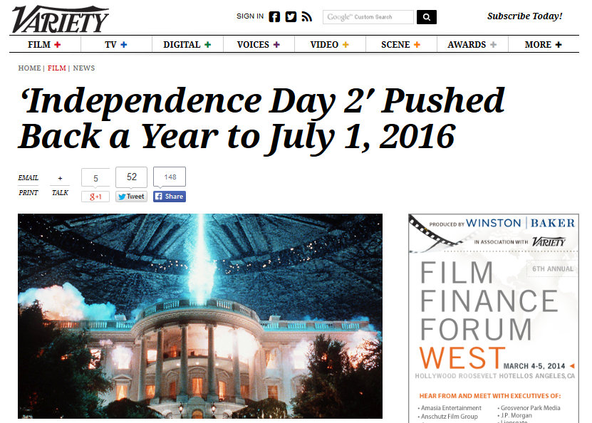
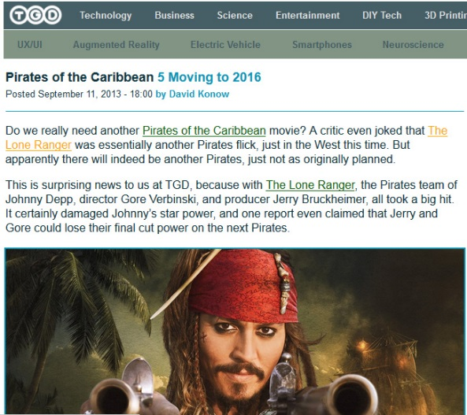
2015’s calendar was so full that movie studios started moving their products to 2016 to maximize profitability.
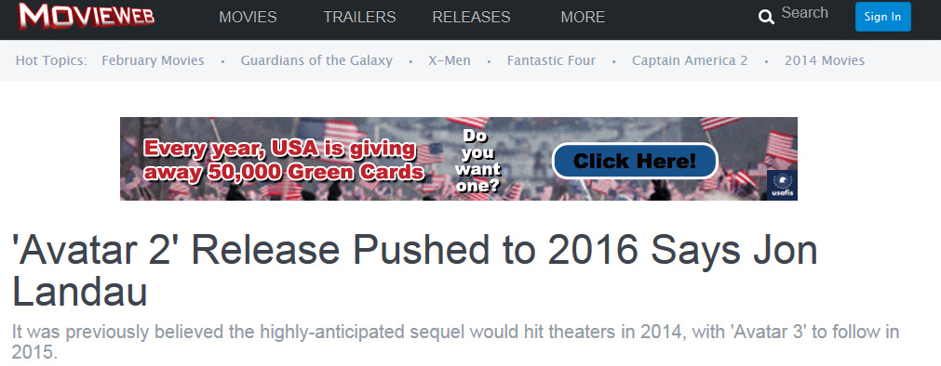
The Biggest News of all was the delay of the MEGA-Franchise Avatar.
This was great news for The Showcase with IMAX. This adds further financial power to an already packed 2016 movie portfolio (Now to 2017). IMAX Franchise Owners are excited because of their special existing relationship with Fox and James Cameron.

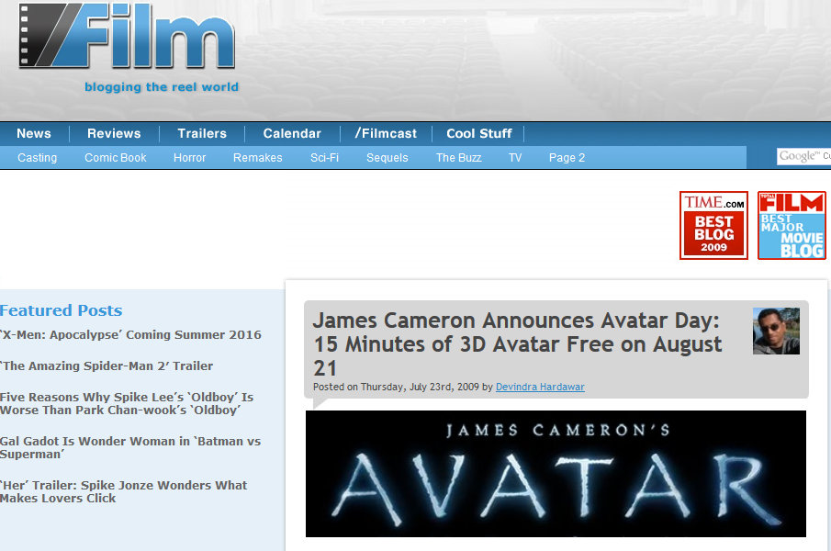
When the first Avatar came out, IMAX owners got an extraordinary launch event.
James Cameron Announced a free 15 minute preview on IMAX Avatar Day at ALL IMAX theaters. This drove millions of movie goers into cinemas with IMAX screens worldwide.
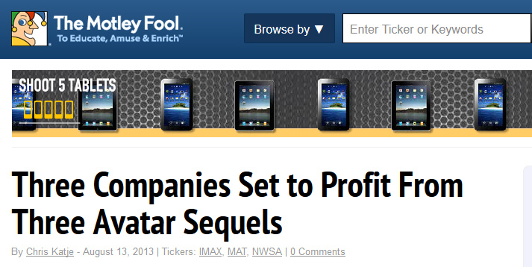
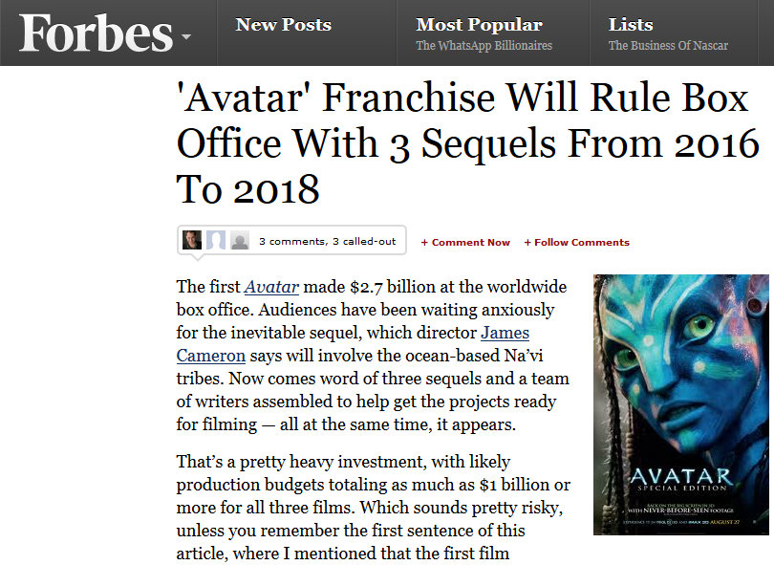
When Industry Observers like the Wall Street Journal and Forbes Magazine evaluate Avatar, they all have the same opinion:
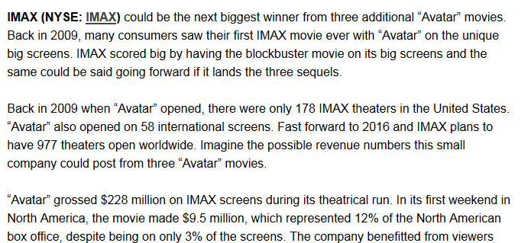
One of them is…………… IMAX.
2017 Movie Slate
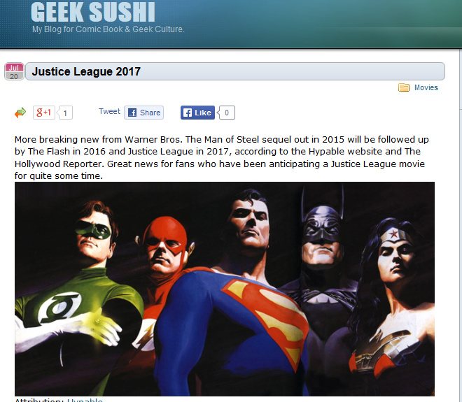
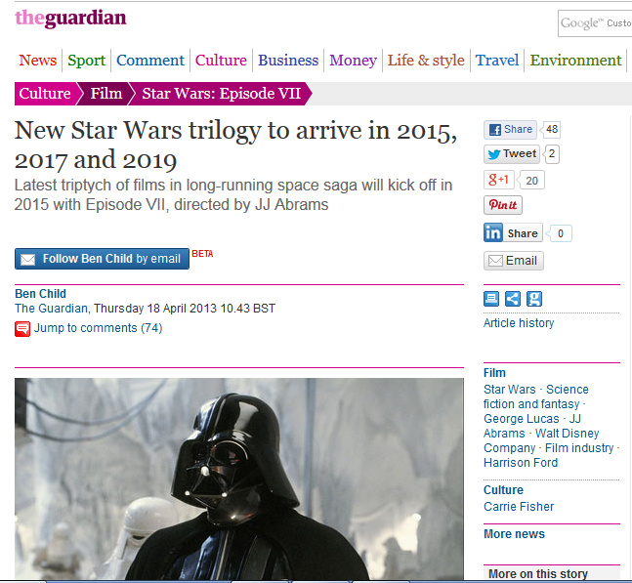
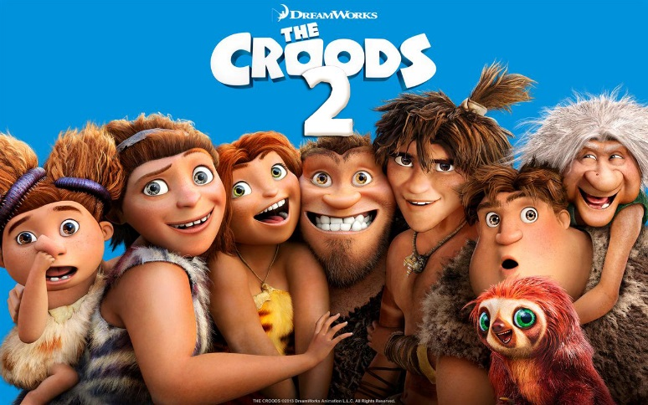
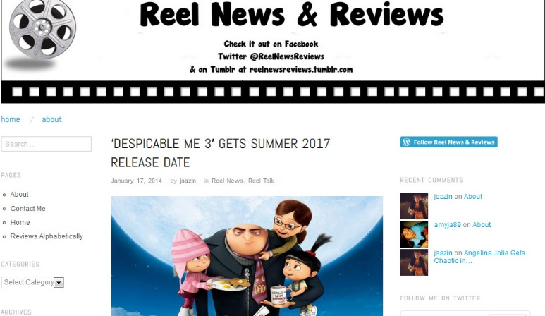
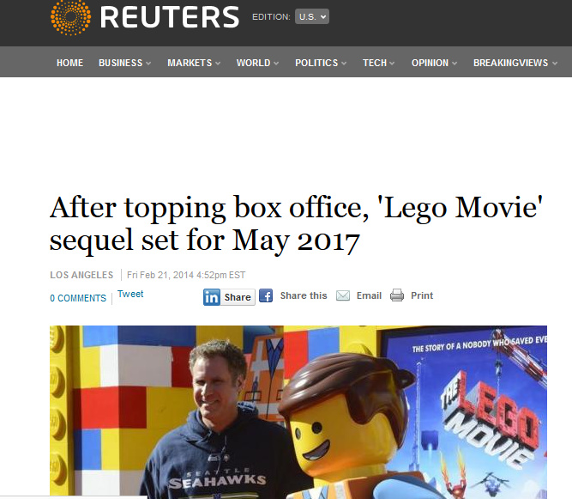

2017 is shaping up to be very strong indeed. With Batman, Avatar and Star Wars sequels on tap, the movie slate is brimming.


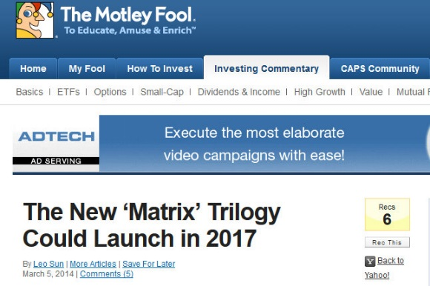
Summary
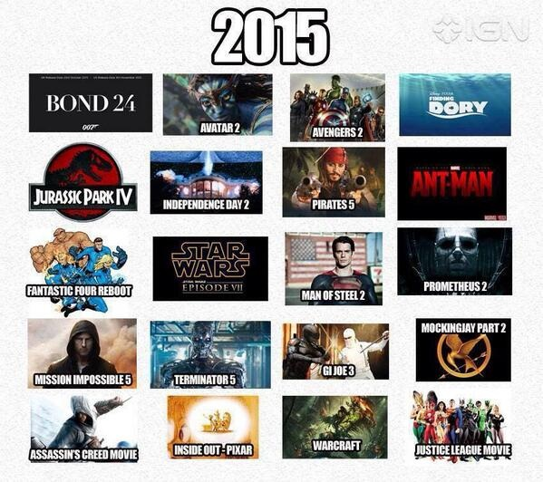
From a Short Term perspective, The Showcase with IMAX’s movie calendar will lead to high profitability.
2016 is targeted for the launch of ‘The Showcase with IMAX’.
From a ‘products’ prospective, the next three (3) years will be quite exciting from an entertainment and financial perspective.
2016 Facility Launch Strategy
An effective launch of the Showcase with IMAX, is the other essential component of short term viability. To properly understand how this will be done a case study has been prepared.
Case Study: Galaxy Cinema launch in Sparks, Arizona
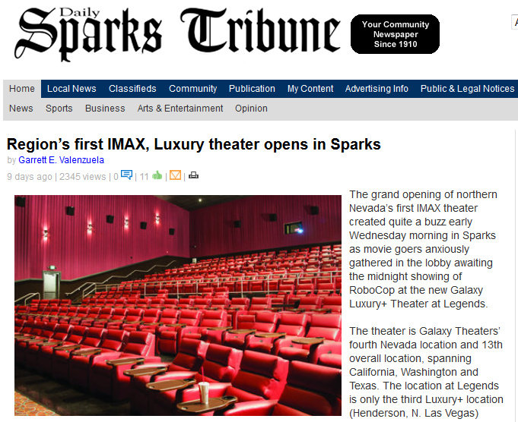
Sparks, Nevada was the site of the latest IMAX/Premium cineplex. The proprietors of this project, Galaxy Cinemas, launched on February 14th, 2014.
Customer Base
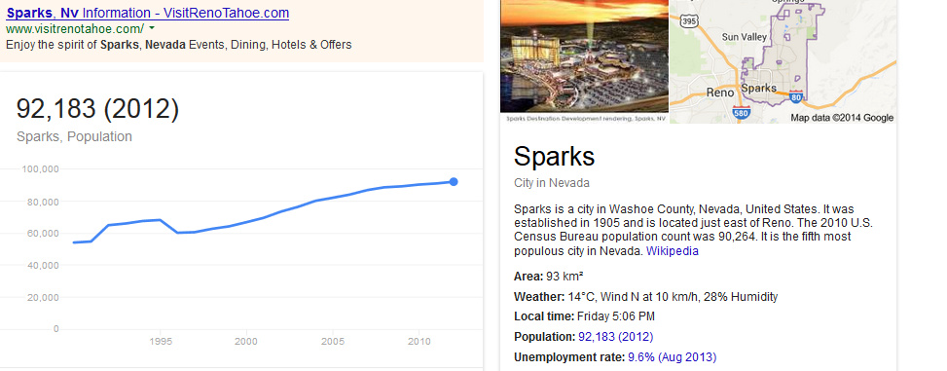
The mantra of premium brands, like 4DX and IMAX, has been their entertainment choices and population density are more important for sustainability than population size.
With a population around 90,000 people, Sparks, Nevada is a prime example of this philosophy. This community, east of Reno Nevada, is small compared to New Providence. Even when adding the surrounding areas that will feed the theater customer base, 180,000 individuals is not reached.
Two Prong Theater Marketing Strategy
A well-defined market entrance approach was divided into Local and Corporate components:
Local Side of Marketing Galaxy Cinemas with IMAX:
Galaxy Cinemas’ marketing strategy revolved around building awareness in a small town. Three of the tactics devised were to use Charity events, Job fairs and Private VIP events (Soft Opening) to reach the community.
Charity Events:
Public screening of previously released IMAX movies were shown with all benefits going toward the family of the late Sparks Middle School teacher Michael Landsberry (killed before Christmas by a student) via the Nevada Military Support Alliance.
This served two purposes:
- Small towns are very complicated, interknitted communities. Showing civic spirit builds loyalty FAST.
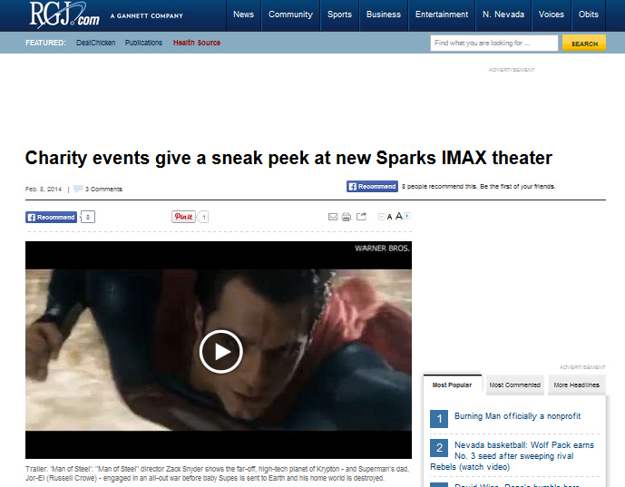
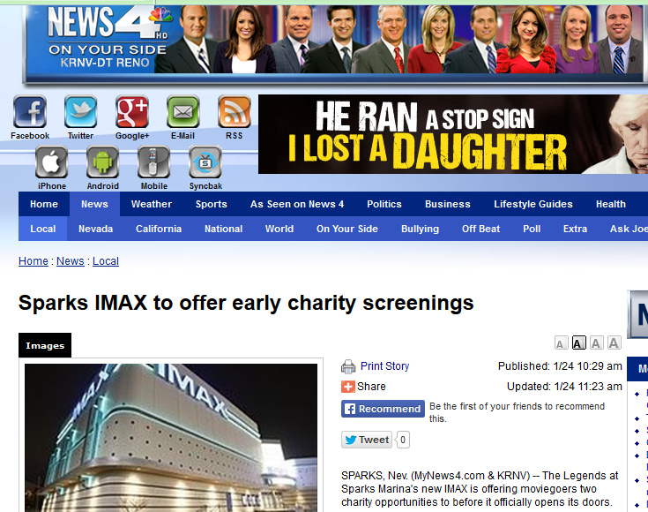
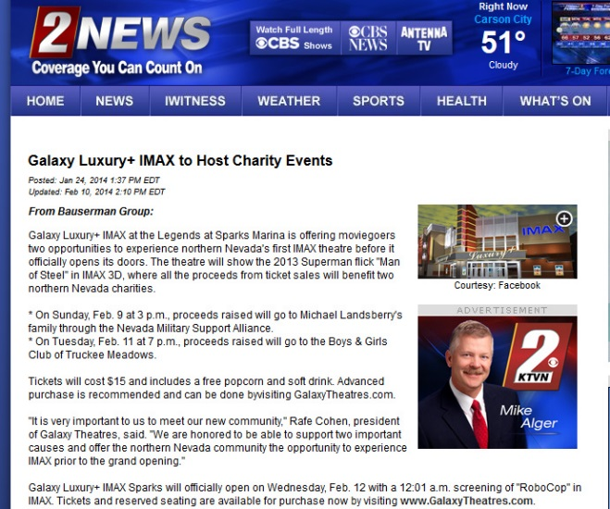
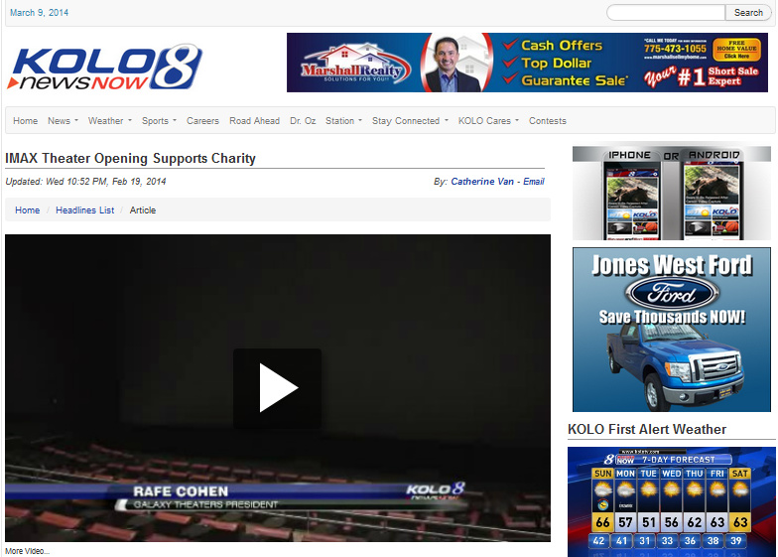
- BIG events in SMALL towns equal FREE media exposure.
EVERY major media outlet in Sparks, Nevada covered it. The Charity event screens were completely sold out.

Job Fairs:
Job fairs in small communities are HUGE for reasons besides finding the right employees:
- Employment choices, by definition, are usually limited.
- Serve as a major marketing tool to begin brand awareness.
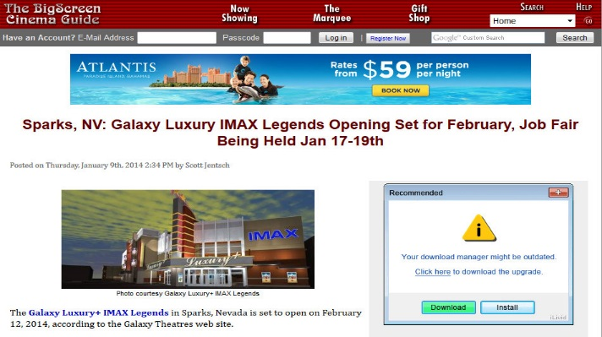
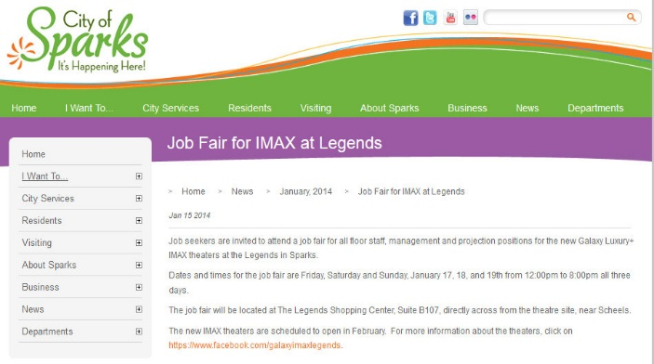
- Fairs become small town news events.
Private VIP Events:
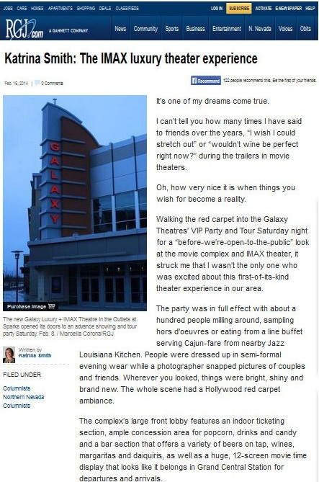
Media, community leaders and local politicians were invited to a black tie event for a soft opening of Galaxy. The aforementioned were blown away.
Rave reviews from local personalities and the media drove the community into a frenzy in anticipation.
Corporate Side of Marketing Galaxy Cinemas with IMAX
Understanding what moviegoers want is the strength of premium brands like IMAX and 4DX.
Movie Goers love two things:
- Free giveaways and exclusive promotions:
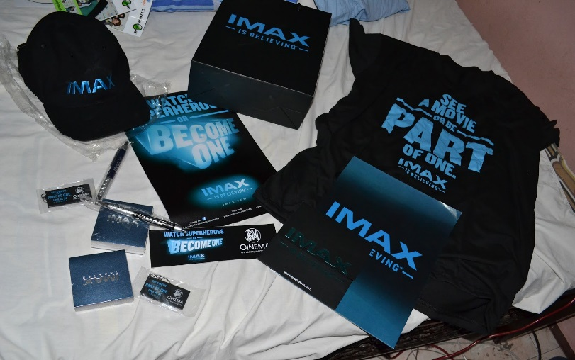

In the case of Galaxy Cinemas with IMAX, the same were schedule to open with a viewing of Robocop on February, 16 2014. Galaxy Cinemas offered the first 1000 free Robocop posters and T-Shirts
- According to Nielson Tracking Company, Movie Goers LOVE watching trailers
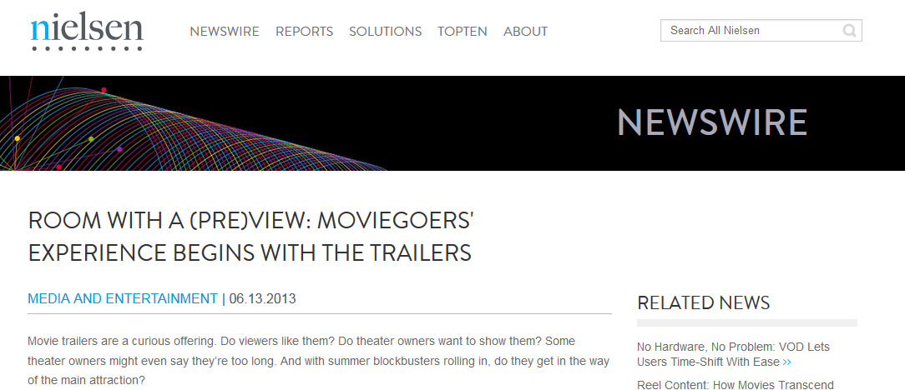

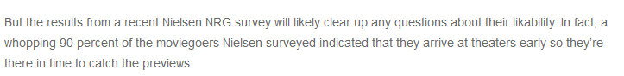
In fact 90% of patrons arrive early to watch previews.
This is why companies like IMAX and 4DX spend so much time securing and making special previews.
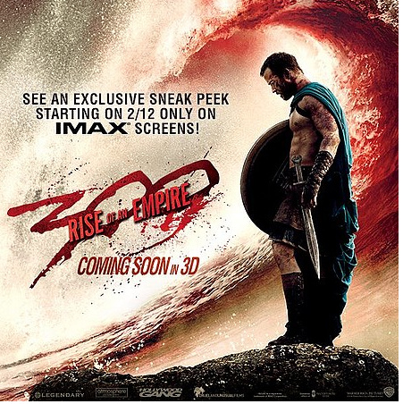
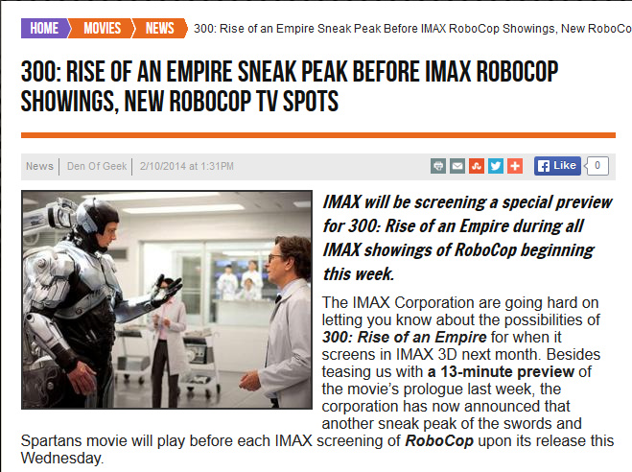
What did IMAX do for network theaters during the ROBOCOP movie launch?
IMAX released an amazing Exclusive 13 minute Preview of the much anticipated 300 sequel during the ROBOCOP launch.

Results:
The concerted local and corporate efforts of the IMAX Corp and Galaxy Cinemas were greatly rewarded:

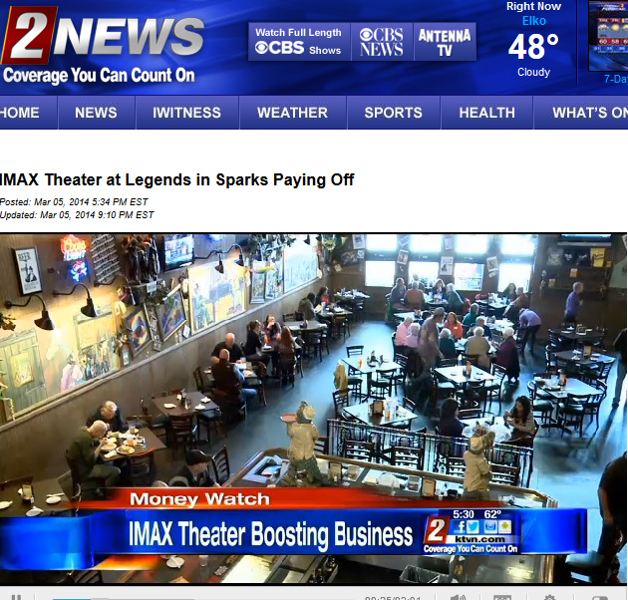
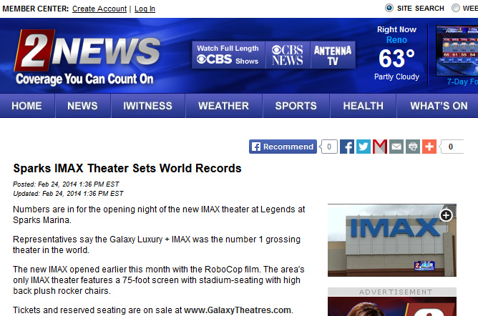
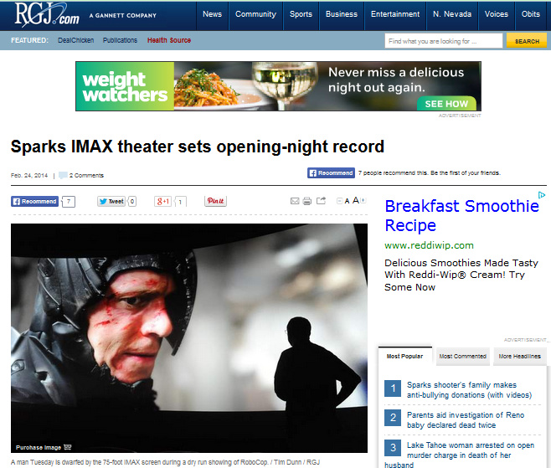
Amazingly this small community produced the largest Box Office GLOBALLY for IMAX. More importantly, because of the already documented ‘Spill-Over Effect’, the entire cineplex produced record regional numbers. The results were not limited to the Box Office.
Surrounding restaurants and eateries in the subsequent weeks have continued to see increased revenue.

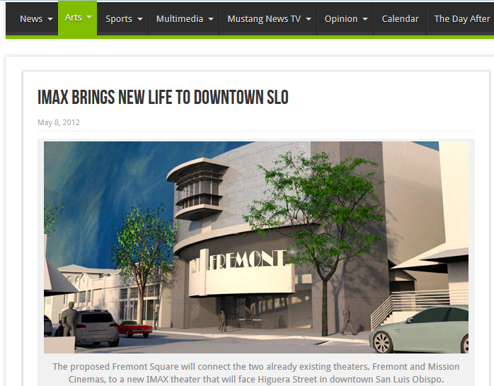
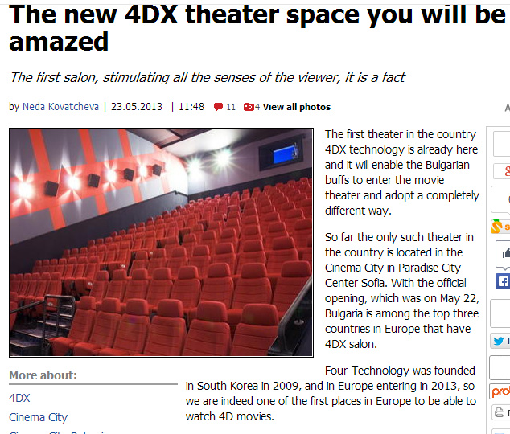
These results are not unique to Galaxy Cinemas in Sparks, Nevada. Premium brands, like 4DX and IMAX, have been using similar set-ups in smaller cities with great results.
Summary:
‘The Showcase with IMAX’ will have all of the tools of IMAX and 4DX to construct a successful launch. This is why these entities have constructed Theater Launch Windows within the confines of their exclusive studio deals.
From a short term perspective, this project has all the components of a financially profitable venture.

